Technical Report: Inventory Management System Optimization

1. Scenario Overview
The development of an Inventory Management System for a high-volume warehouse necessitates a focus on high-performance data handling. The primary requirement is to store product details while enabling near-instantaneous operations for adding, updating, and deleting records. With inventories potentially exceeding tens of thousands of products, selecting an optimal data structure is critical to maintain system responsiveness.

2. Problem Analysis

2.1 The Importance of Algorithms and Data Structures
In systems with minimal overhead (e.g., 10–20 items), simple linear lists are sufficient. However, at a scale of 10,000+ items, linear search times significantly degrade user experience. Key performance indicators include:

- Fast Search: Retrieving product information by unique ID must occur in constant time regardless of dataset size.
- Efficient Modifications: Warehouse operations require frequent additions, updates, and deletions.
- Memory Efficiency: The system must utilize memory judiciously while avoiding unnecessary overhead.
- Scalability: Performance must remain stable as the inventory grows.

2.2 Comparative Analysis of Data Structures

Data Structure | Pros | Cons
ArrayList / List | Simple implementation; maintains order. | Slow search (O(n)); slow deletions.
Dictionary / HashMap | O(1) average time for CRUD operations. | No guaranteed order; memory overhead.
Sorted List / BST | Maintains sorted order; range queries. | Implementation complexity; O(log n) time.

Note: For this implementation, Dictionary<int, Product> was selected as the optimal choice to provide O(1) average time for primary operations using the unique productId as the primary key.

3. System Implementation
The solution is built within the InventoryManagement namespace, utilizing a clean separation between data modeling and logic management.

3.1 Product Data Model
The Product class encapsulates the essential attributes of warehouse stock:

- ProductId (int): Unique key for lookup.
- ProductName (string): Descriptive name of the item.
- Quantity (int): Current units in stock.
- Price (double): Unit valuation.

3.2 Inventory Logic and Methods
The InventoryManager utilizes a Dictionary to jump directly to memory addresses via hashing, bypassing the need for sequential iteration.

- AddProduct: Implements a safety check using .ContainsKey() to prevent duplicate Product IDs before insertion.
- UpdateProduct: Utilizes TryGetValue() to locate records efficiently, allowing for partial updates to specific fields without requiring full object replacement.
- DeleteProduct: Employs the .Remove() method for direct key-based deletion.
- SearchByName: Integrated via LINQ to provide case-insensitive filtering for keyword matches.

4. Performance Analysis
The following table summarizes the time complexity of the system operations based on the selected hash-mapped architecture:

Operation | Time Complexity | Logic / Reason
Add (Product) | O(1) Average | Direct placement via hash slot.
Update (Product) | O(1) Average | Instant lookup via hash key.
Delete (Product) | O(1) Average | Key-based removal.
Search by Name | O(n) | Requires full scan of the collection.
Display Inventory | O(n) | Iterates through every entry.

5. Optimization and Future Scalability
While the current Dictionary-based approach is highly efficient for ID lookups, further enhancements can be made for large-scale enterprise environments:

- Secondary Indexing: Implementing a secondary dictionary for ProductName to reduce search complexity from O(n) to O(1).
- Concurrency: Transitioning to ConcurrentDictionary to handle simultaneous multi-user access without race conditions.
- Storage Evolution: Transitioning from in-memory storage to integrated database systems like MongoDB for persistence and advanced auditing.

Output:
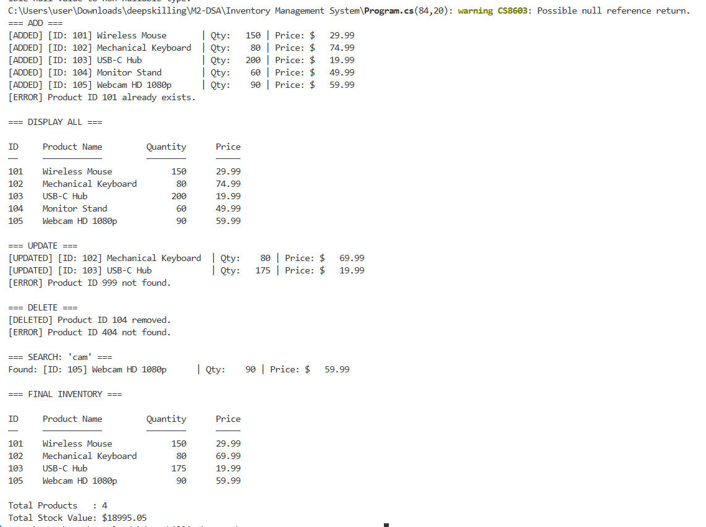

6. Summary
By prioritizing the correct data structure, this Inventory Management System achieves maximum efficiency for its primary operations. Testing with a sample set of products confirmed successful duplicate detection, flexible updates, and robust deletion logic. Selecting a Dictionary structure ensures the application remains performant even as warehouse demands scale.

